**Quick Start Guide**

Install* the package using the instructions in the Installation Guide. Then, to use the package, open a notebook and start your session with the statement Needs ["GeomAlg2019Oct`"] or, equivalently, <<"GeomAlg2019Oct`". If you open a 2nd notebook later, it also must begin with the “Needs” statement. You can use the palette to quickly enter the needs statement.

The palette has been designed as an instrumental part of this package and should be installed before proceeding. Simply open the notebook Geom Alg Palette 2019Oct.nb, run it (i.e., put the cursor anywhere within the code and press SHIFT ENTER) to display the palette, move it to your preferred default location, and select Install Palette ... from the Palette menu. Select Geometric Algebra (GA) Palette from the Source drop-down menu, give the palette any name, for example Geometric Algebra, and click OK. If you later wish to change the default palette location, simply move it.

The first time you close the palette it will ask if you wish to save it. You may, but it is not necessary. You already have the source code and can regenerate it any any time. After you close it you can re-open it from the Palette menu by selecting the name you just gave it.

If you find any items too small to read, click on the magnification box at the bottom.

Step 1 is to use the palette to select your GA initialization. You can change this on-the-fly without having to quit either the kernel or Mathematica. Next, you can use the palette to quickly enter vectors, bivectors, blades, and general multivectors (which I often call clifs, for Clifford, because clif is shorter than multivector and helps keep the palette narrower). The palette not only shows you all the available commands, it illustrates many of them and has tooltips for all of them. Thus, it is your on-screen documentation center as well as your user interface. Click on the triangles to expand/contract sections.

The file "Examples" can be examined to see how most of the operations work. I

The file “Documentation” is quite short and provides numerous important tips.

Caution: If Mathematica 10 or later displays the “shadow errors” bug, you may wish to read the work-around in the main documentation.

* This package was developed and tested only on a Mac. Windows users may need to install a font that recognizes the binary operator symbols Diamond, Wedge, CenterDot, Star, LeftTee, and RightTee, shown here:

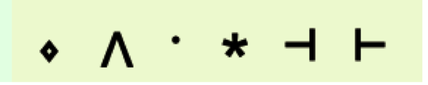

If the symbols are visible in the palette, then no font change is required.